The Morrinsville Gallery
167 THAMES STREET,10AM-3PM TUES TO FRI& 11AM-3PM WEEKENDS

EXHIBITION PROPOSAL INFORMATION PACK
Whakaaturanga/Exhibition Gallery | Community Gallery

Gallery Hours: Tuesday – Friday 10am–3pm, Weekends 11am - 3pm
The Morrinsville Gallery is made up of three gallery spaces, located in a prime spot on Thames Street, Morrinsville.
Our gallery has an excellent reputation for showcasing the work of New Zealand’s finest established and emerging artists. Over 20,000 visitors come through our doors each year from all over New Zealand and the world.
We offer exceptional administration and curatorial services, a high-profile space, good foot traffic, likely sales, promotion, the opportunity to be a part of our public programme, and the chance to exhibit alongside works from The Arts House Trust Collection.

We welcome your proposal to exhibit in either the Whakaaturanga/Exhibition Gallery or the Community Gallery. Please note, The Arts House Trust Gallery is reserved as a space to showcase works from the collection throughout the year.

The Gallery is located at 167 Thames Street, Morrinsville 3300, New Zealand +647 889 779 info@morrinsvillegallery.org.nz
WE LOOK FORWARD TO RECEIVING YOUR PROPOSAL THROUGH THE GALLERY WEBSITE. A 40% commission (GST inclusive) on all sales is payable to The Morrinsville Gallery. Commission earned from sales is in addition to the gallery hire fee.

Prices to hire gallery spaces;
* GST included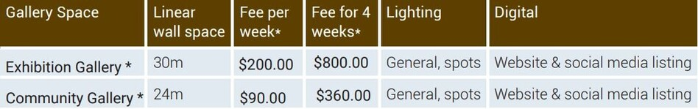

GENERAL GALLERY INFORMATION
The Morrinsville Gallery floor plan
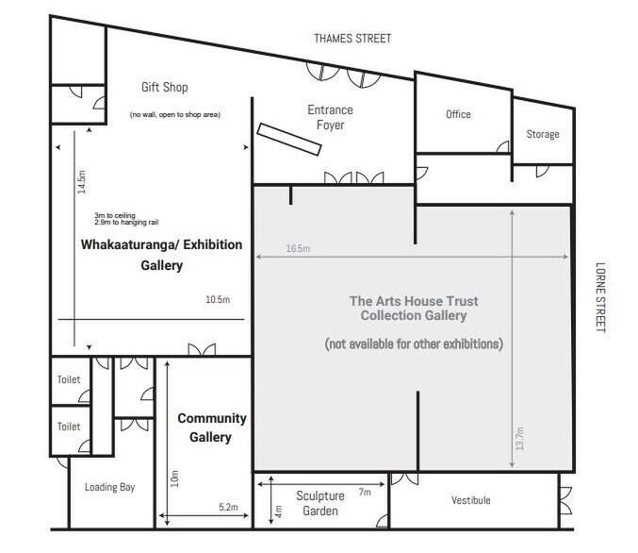

Whakaaturanga | Exhibition Gallery:
Exhibitions within our second largest space run for a 3–5-week period (including install and uninstall of artworks) depending on the exhibition programming. You can apply to present a solo or group show. Artists pay $200.00 per week.

Community Gallery:
Our Community Gallery is a space to showcase the work of artists who have a connection with the Matamata-Piako District or the wider Waikato Region. This space is especially reserved for exhibitions from schools, community groups and charities, but is also suitable for experimental and smaller solo and group exhibitions. Artists pay $90.00 per week. Free for schools.

Hanging of work in the Exhibition and Community Galleries:

ALL WORK DELIVERED TO THE GALLERY MUST BE READY TO HANG

The Morrinsville Gallery uses a French Rod Picture Hanging System which will be a consideration as you prepare your works for exhibition.
Where possible, attach D-rings to the back of your work close to the top of frame. If you want the hanging system hooks to be hidden, you will need to place the top curve of the ring at least 50mm from the top of the frame.
Or you may choose to show the hooks, in which case the top of the D-ring curve would be placed between 10-20mm from the top of frame.
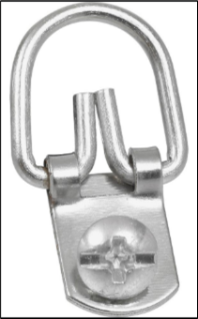
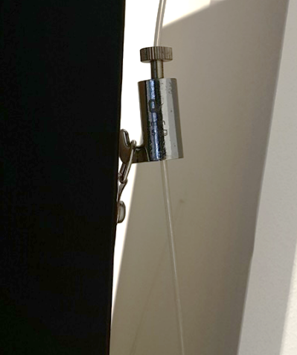

Morrinsville Gallery’s Responsibilities:
-The Morrinsville Gallery will design posters and What's On brochure.
-Email invitations via the e-newsletter to The Morrinsville Gallery database of artists and supporters (approx. 1000 people).
-Provide digital copies of the exhibition poster to artist to enable distribution to networks.
-Promote in the Morrinsville News and on Creative Waikato website.
-Forward publicity details and artist contact details to appropriate media, though coverage cannot be guaranteed.
-Add exhibition details to The Morrinsville Gallery website and other websites that The Morrinsville Gallery deems relevant and appropriate. Details also on gallery Instagram and Facebook.
-Attend to design and presentation of wall text (you provide decals), individual labels and price lists.
-Installation of exhibition (artist involvement negotiable).
-Guarantee of a high standard of care and skill when handling works.
-Demount works and have ready for collection on agreed date.
-Offer a combined Saturday opening/preview 11am to 12.30pm and provide gallery staff to host the opening.
-Provide coffee and tea refreshments at the opening.
-A XERO invoice will be emailed with deposit amount and full payment details.

Artist responsibilities:
-Have all exhibited works for sale (unless agreed upon).
-Return all requested documents and information within the required timeframes.
-Deliver the works to The Morrinsville Gallery ready for installation on the date agreed with D rings attached.
-Cover the cost of delivery to and return of art works from The Morrinsville Gallery, the works must be delivered in a form ready for installation (i.e. named and ready for hanging).
-Arrange insurance appropriate for the works while they are on The Morrinsville Gallery premises and in transit.
-Supply an electronic image .jpg file (300dpi) of a work to be exhibited, confirm exhibition title, media description, bio and artist statement 5 weeks before exhibition.
-Provide a Word document with titles, media, size and prices 2 weeks before exhibition.
-Discuss any deviation from the original proposal/arrangement with The Morrinsville Gallery Director at least one month before the exhibition start date.
-Provide installation details/requirements two weeks prior to the opening.
-Be responsible for any ‘installation style works’, in consultation with the The Morrinsville Gallery Director.
-Pay a 20% deposit of the exhibition fee three months before the exhibition opening date. Pay the rest of the fee in full at least four weeks prior to the exhibition opening date.
-Work delivered to the gallery must be wrapped in such a way that it can be re-wrapped suitably for the potential buyer on pick up.
-Provide any food for the Saturday morning opening.
-Collect any unsold works from the The Morrinsville Gallery within five working days after the end of the exhibition (negotiable).

Once accepted as an exhibitor you will be required to sign an exhibition agreement form before the exhibition is finalised. Please ask to see this form if you would like to view the terms and conditions in advance.

HOW TO APPLY FOR AN EXHIBITION
Complete the Exhibition Proposal Form on the gallery website, providing as much information as possible to help us assess which gallery and timing is the most suitable to accommodate your proposal.

PROPOSAL PRESENTATION
• Please provide up to 300 words describing your proposed exhibition and your art practice.
• Please include 3 to 5 high resolution quality coloured .jpg digital images uploaded with the application. Label images/file with title, medium, size and date. Please note that physical images are not accepted.
• These images must demonstrate the nature and quality of your work.
• Examples may be of previous work that is strongly relevant to the proposed exhibition.
• Please provide links to your website and social media pages.

The Morrinsville Gallery strives to select a variety of artists to ensure a well-rounded exhibition schedule. All proposals will be considered by a selection panel and only successful applicants will be notified. Applicants who are accepted into the exhibition schedule will be notified no later than four weeks after their proposal is received.

